To get the Static Code quality result, you need to install this plugin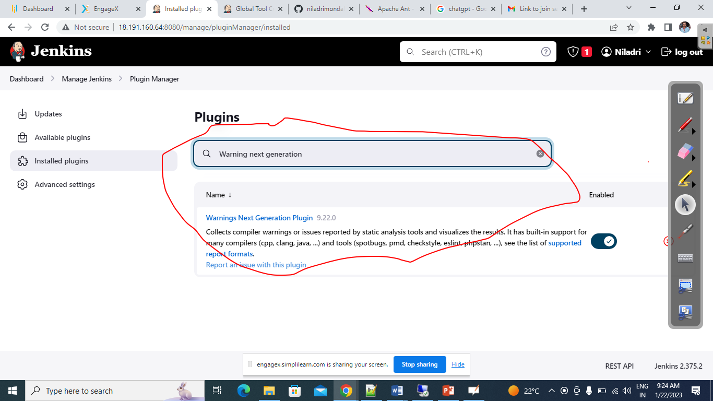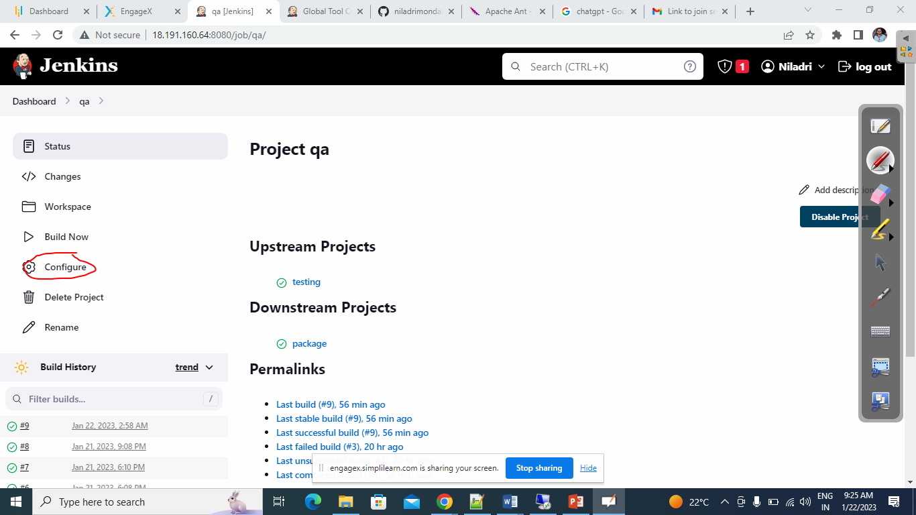

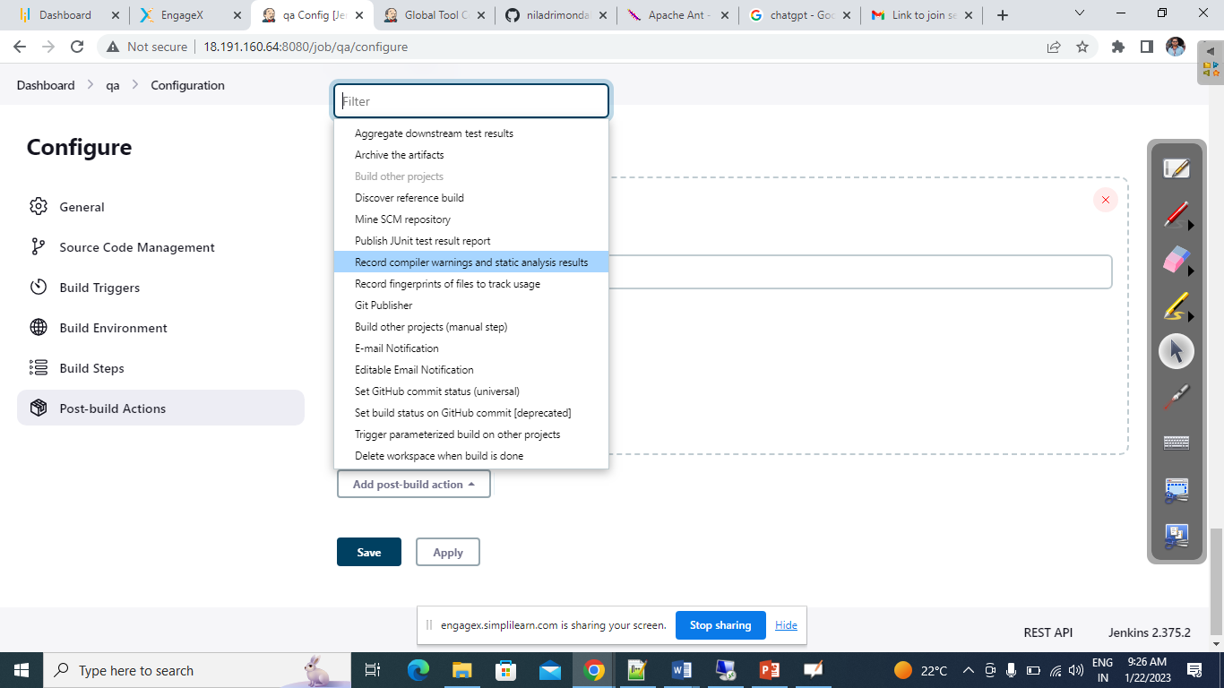

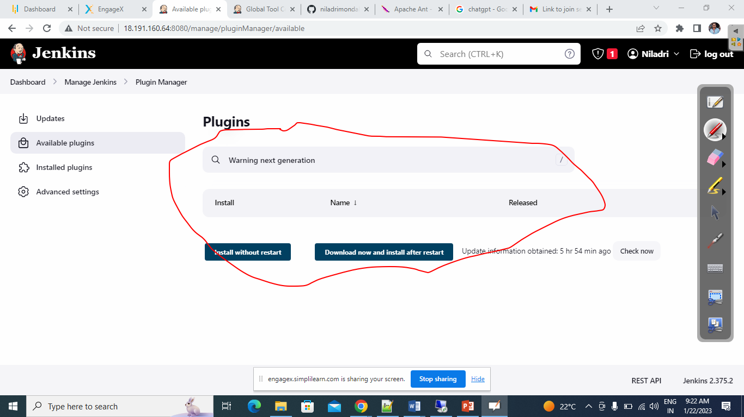

Based upon you Maven build command select the above tool.

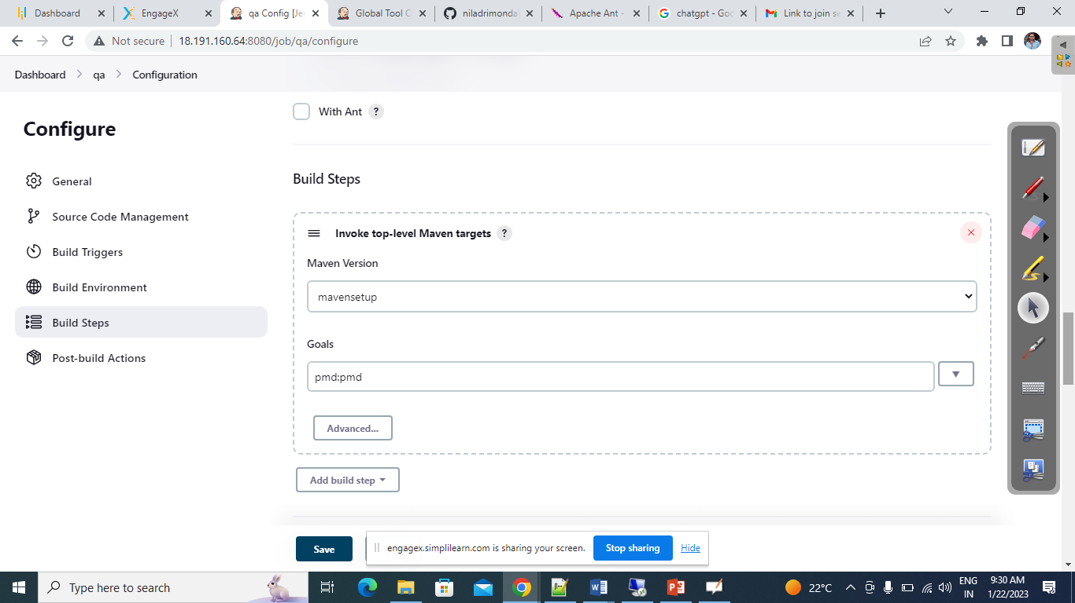

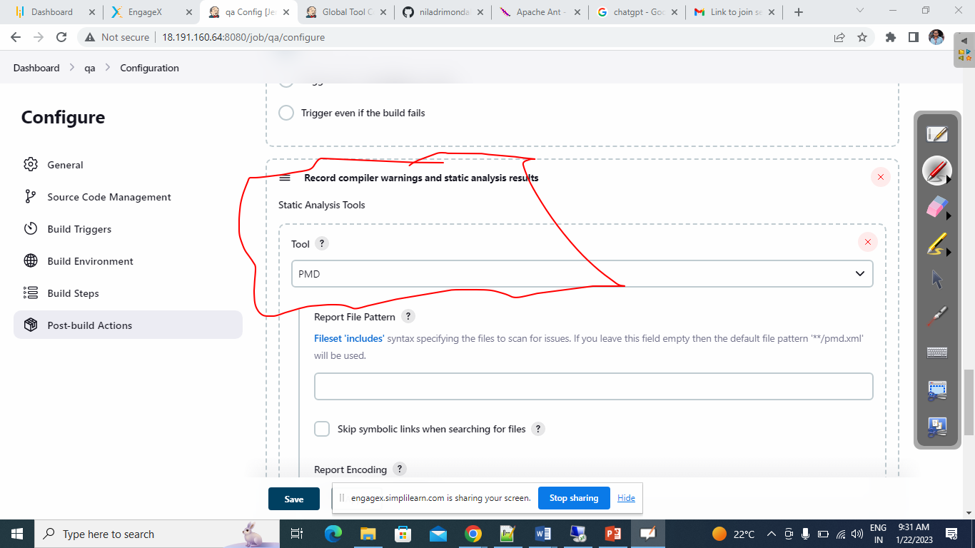

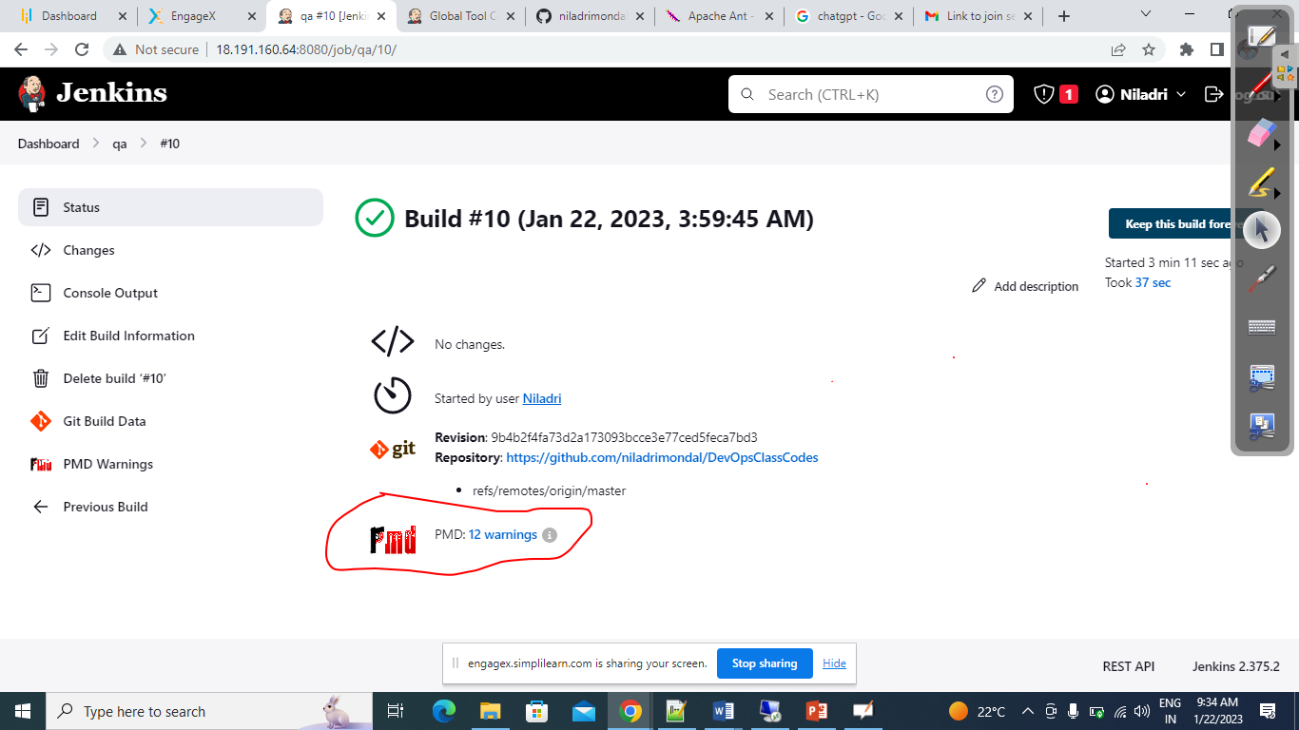

We are now going to build a project using Apache Ant

1. Download the Apache Ant
2. Configure the Same in you ENV
3. Integrate the Same in Jenkins

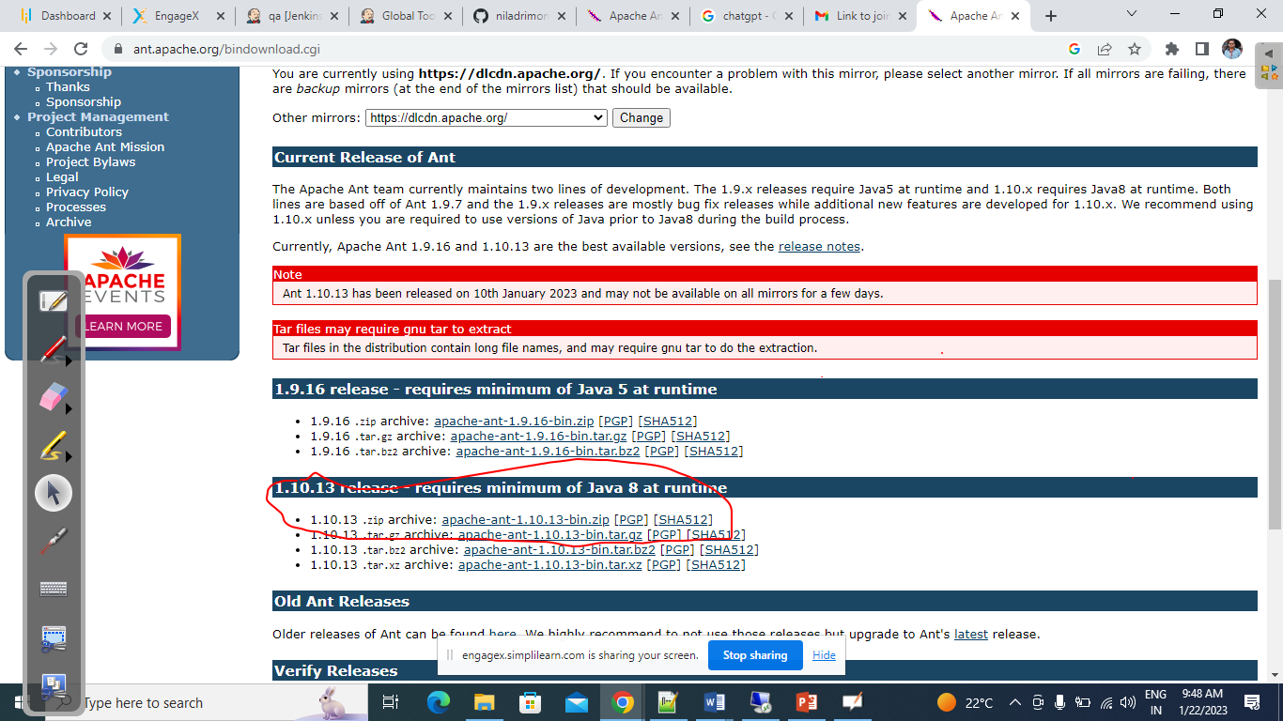

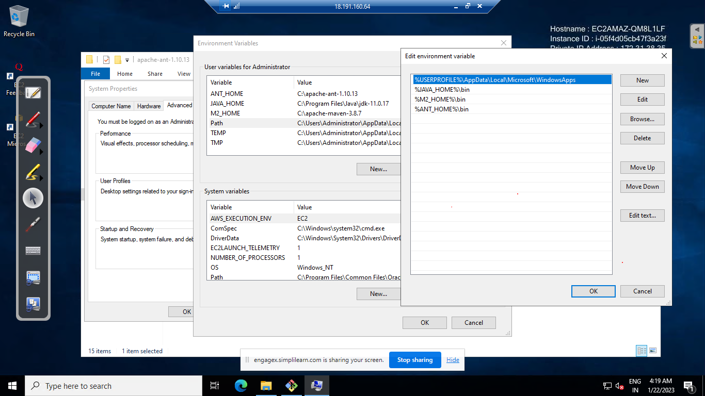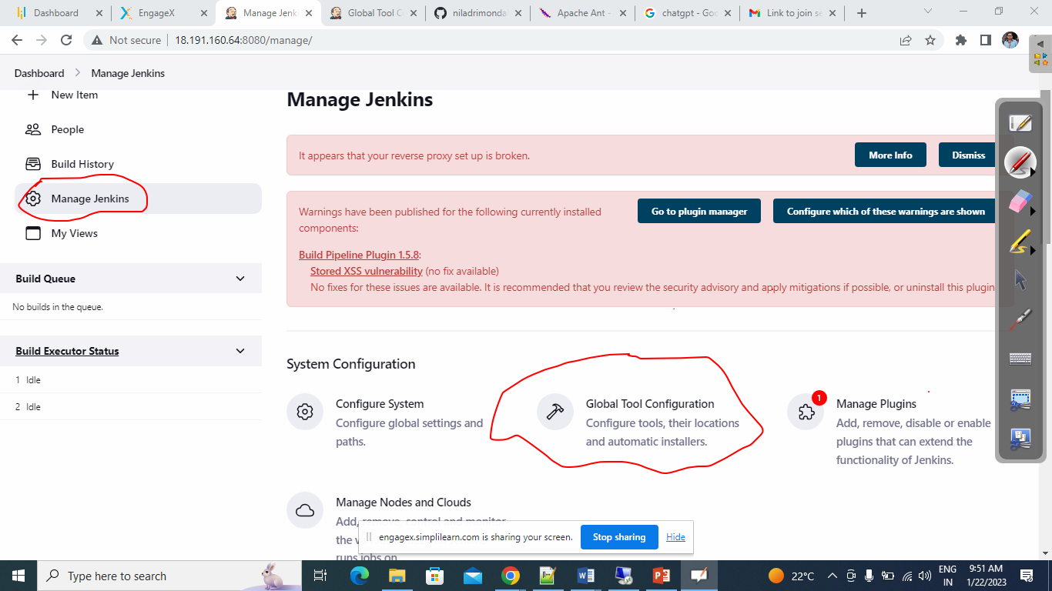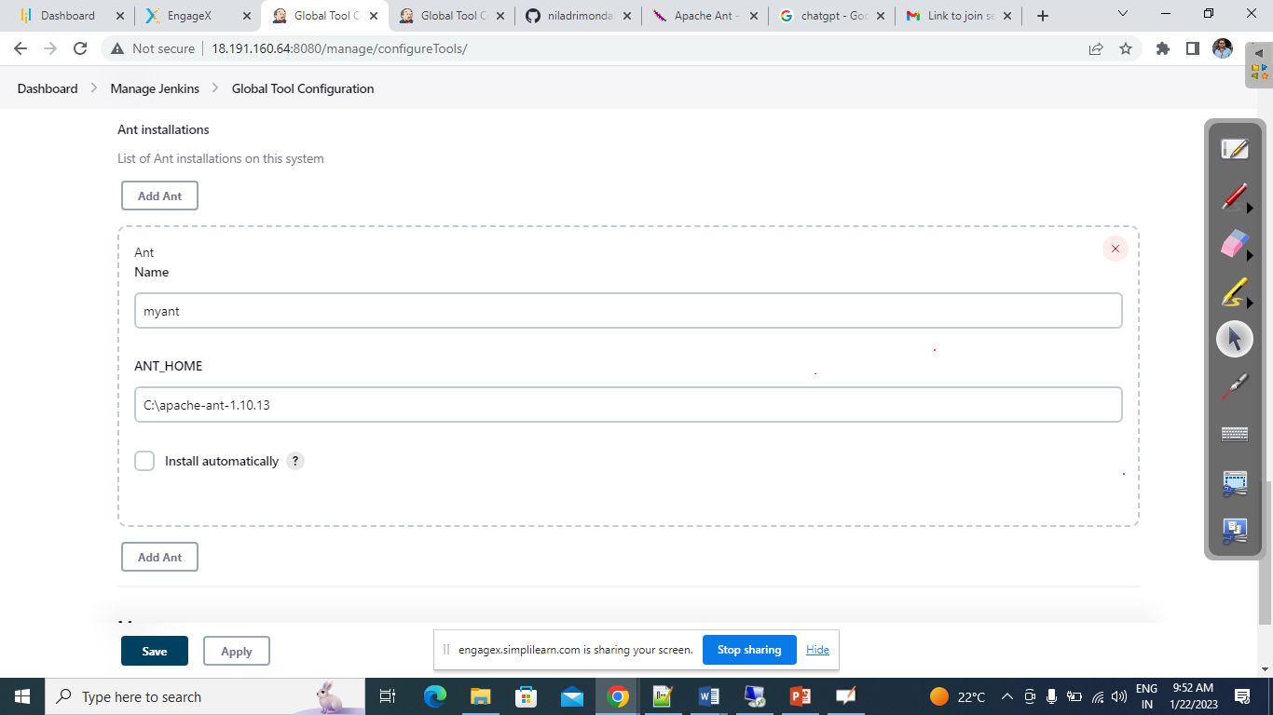

Create The Jenkins Job to Build an ANT project

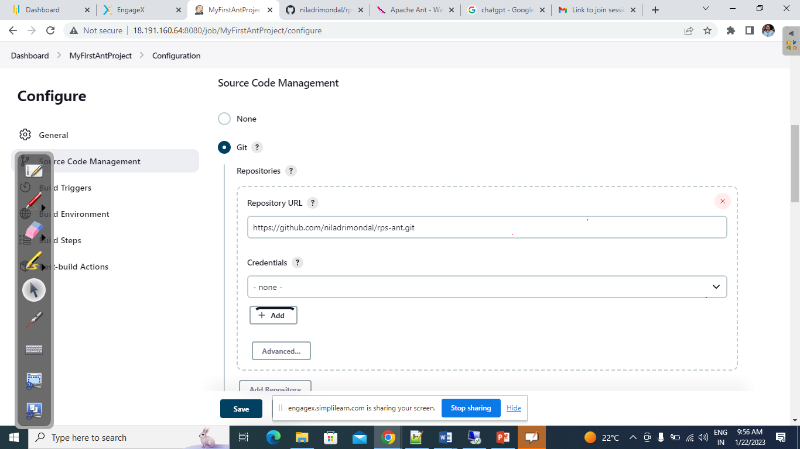

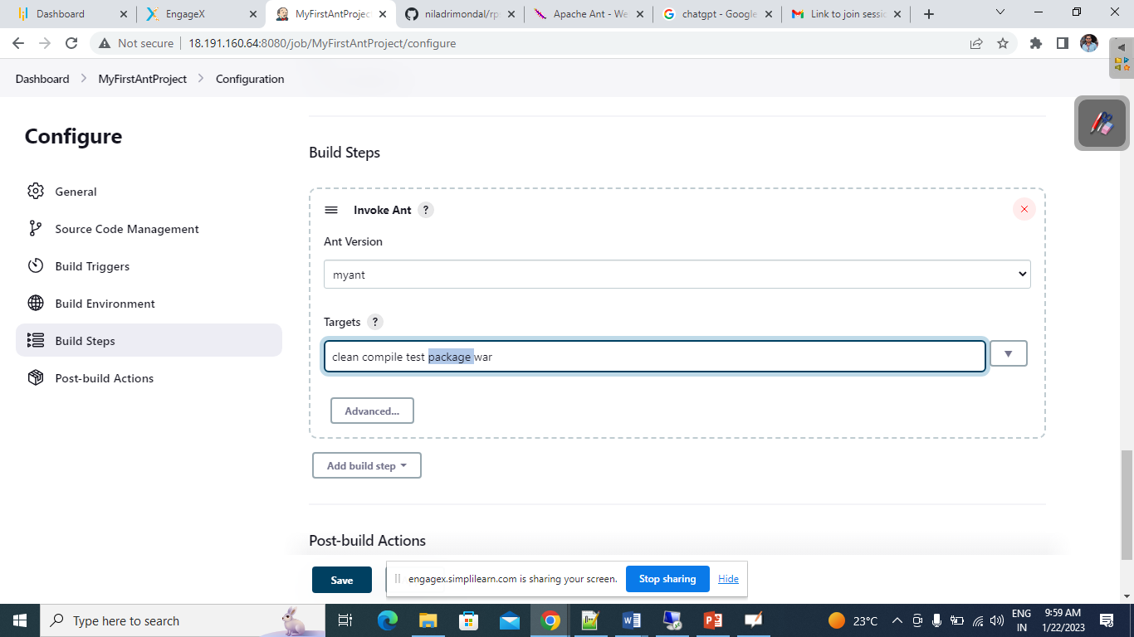

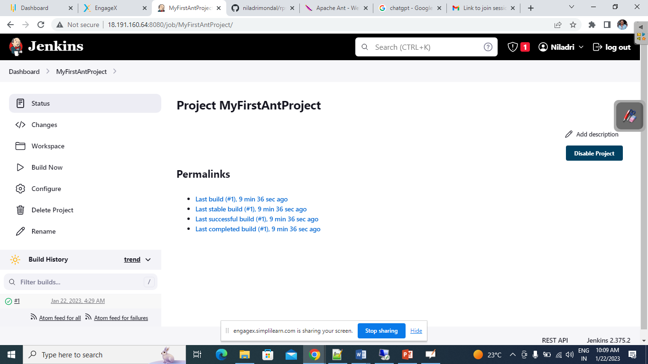

++++++++++++++++++++++++++++++++++++++++++++++++++++++++++++++++++++

We are going to Do Parameterize build

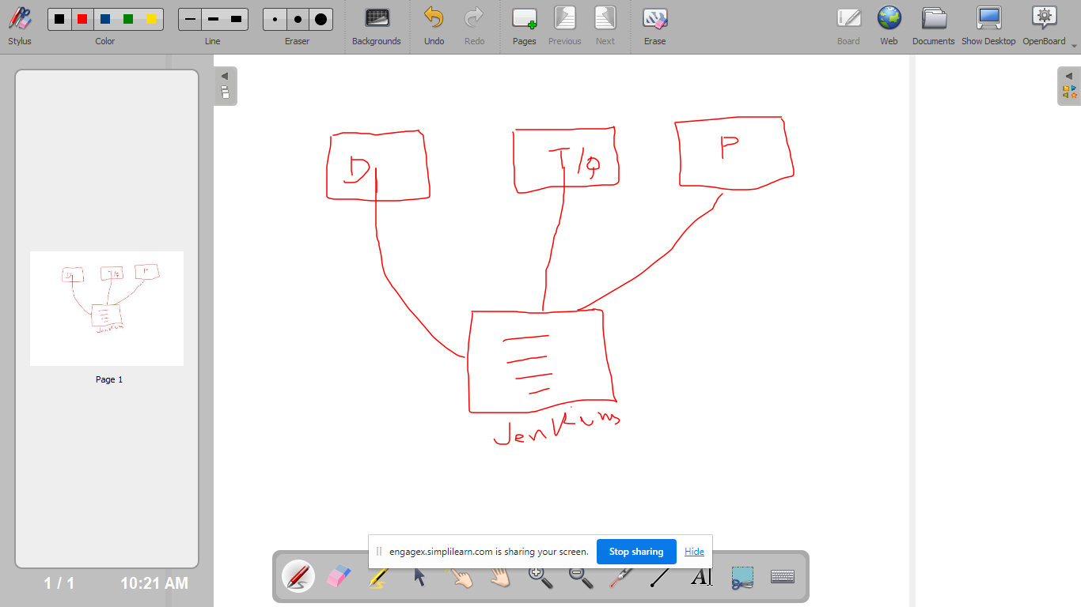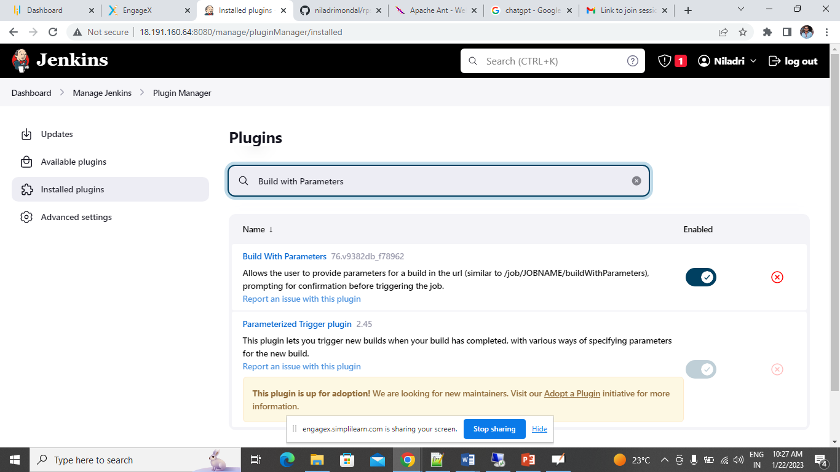

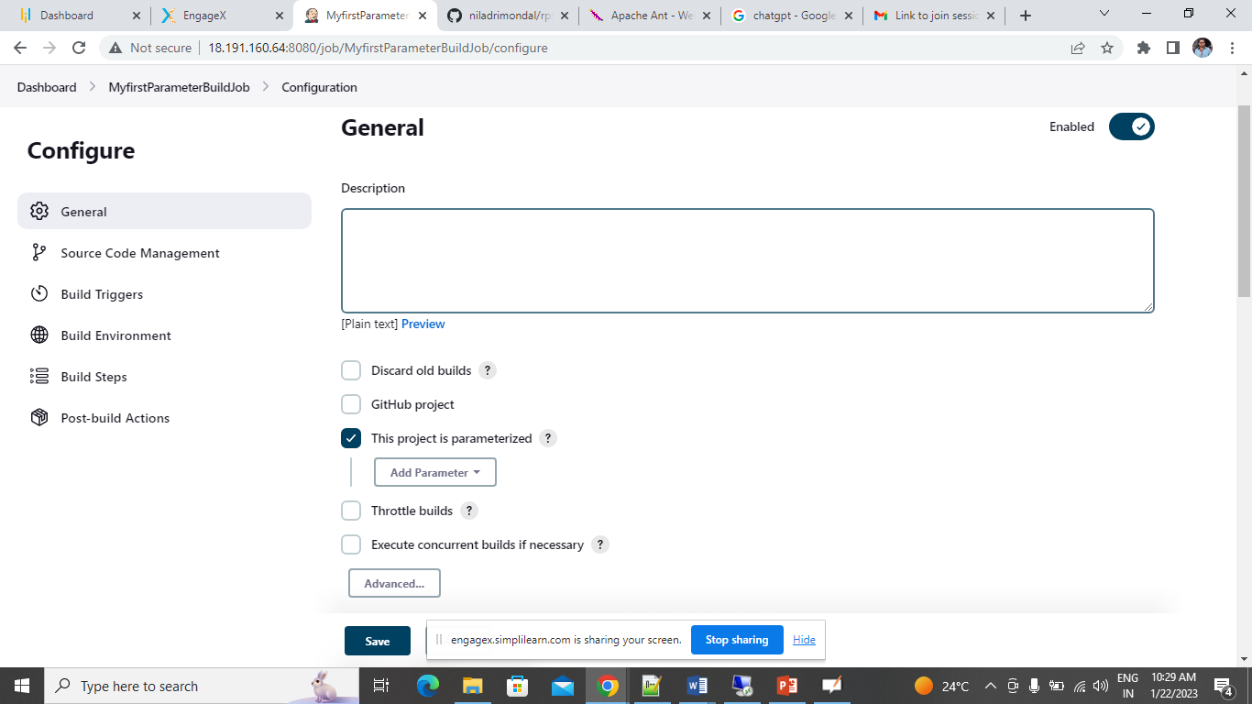

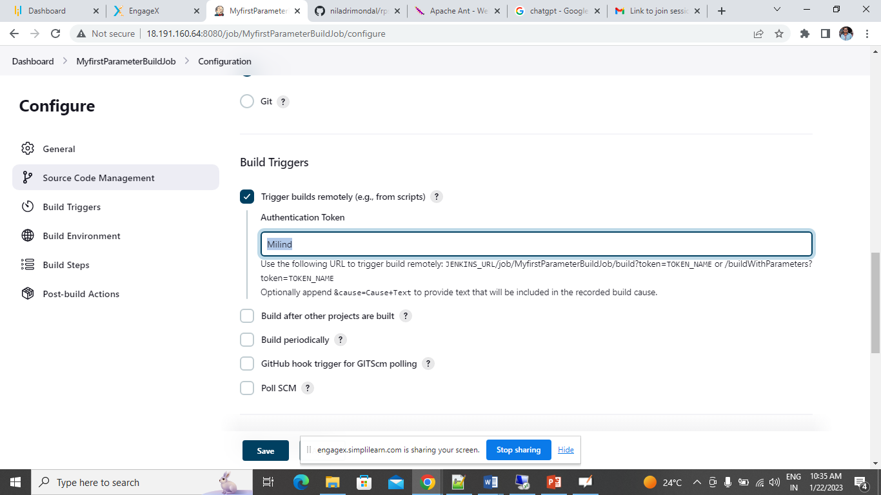

http://localhost:8080/job/MyfirstParameterBuildJob/buildWithParameters?token=Milind

<http://18.191.160.64:8080/job/MyfirstParameterBuildJob/buildWithParameters?token=Milind>

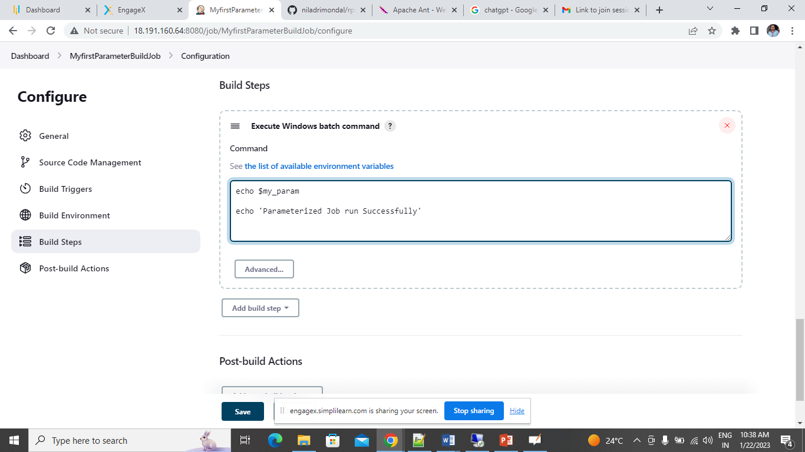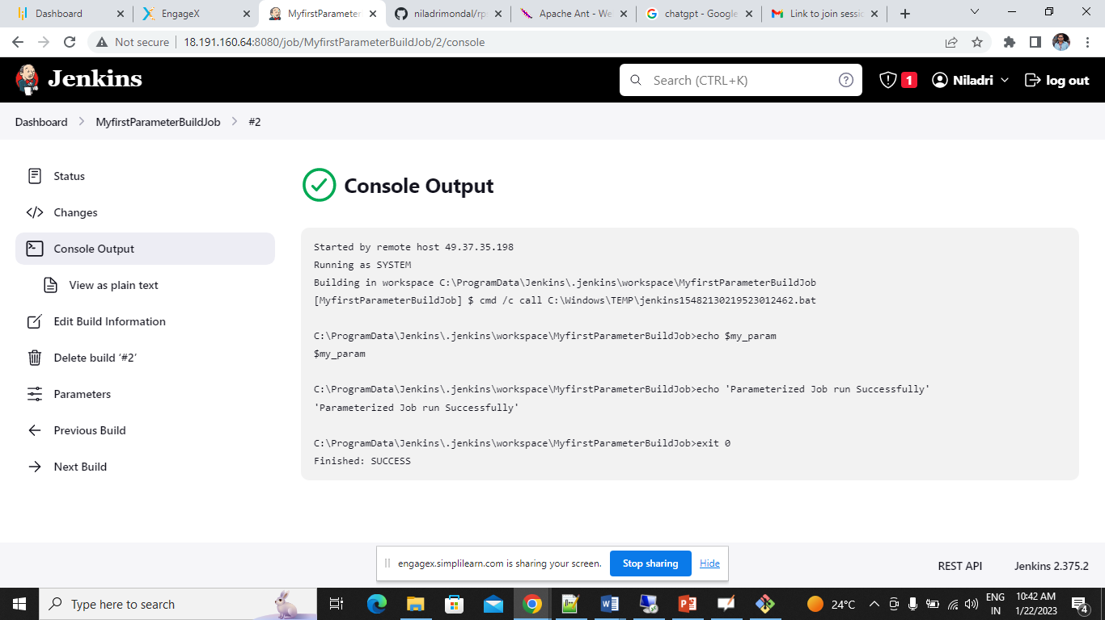

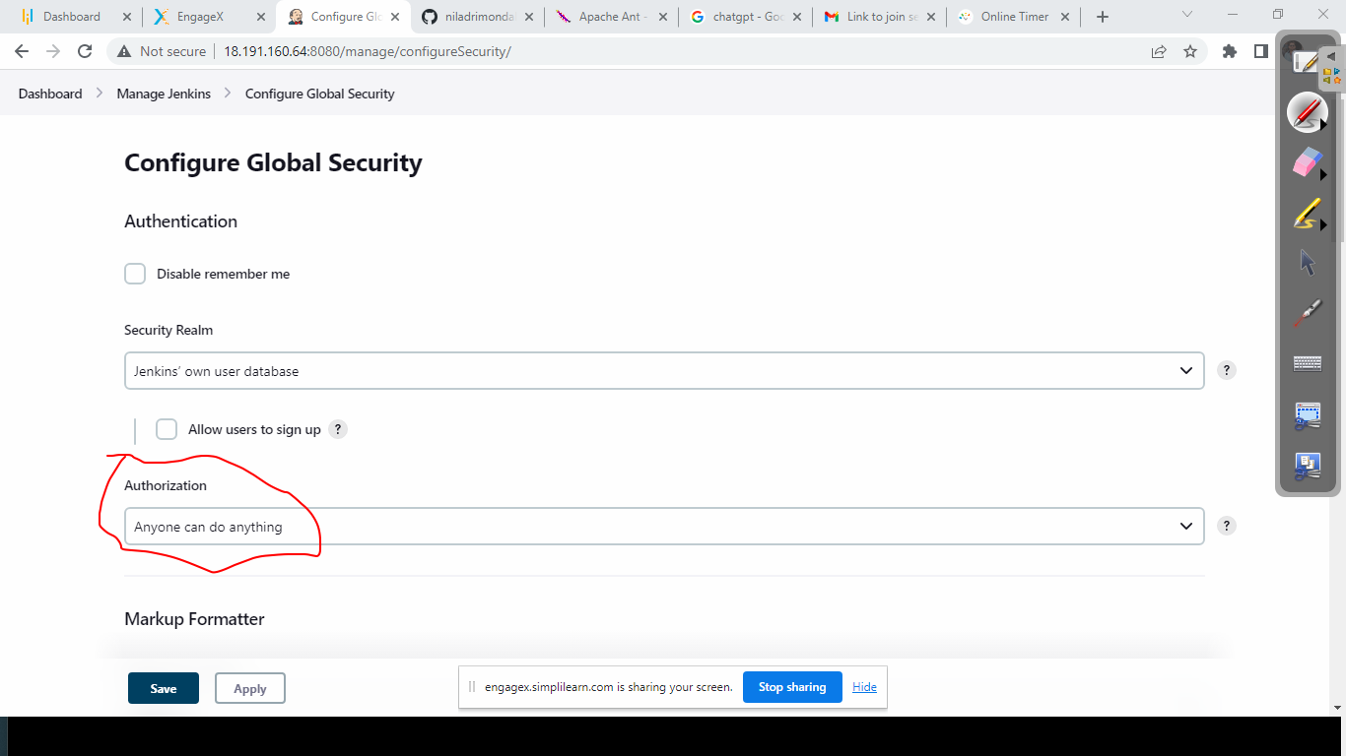

++++++++++++++++++++++++++++++++++++++++++++++++++++++++++++++

Pipeline write groovy script to create CICD process

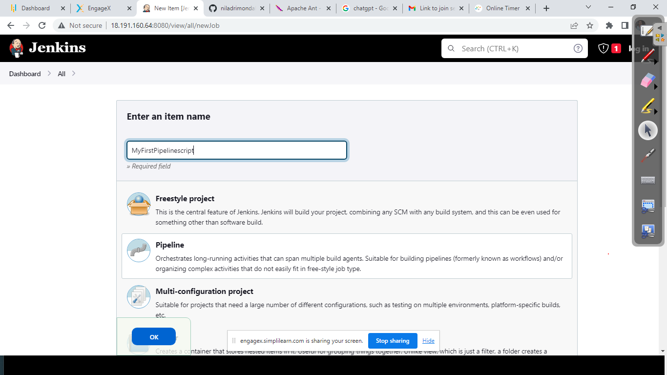

Now we are going to Write Some script to build a Maven Project.

Identify your maven environment name in the below

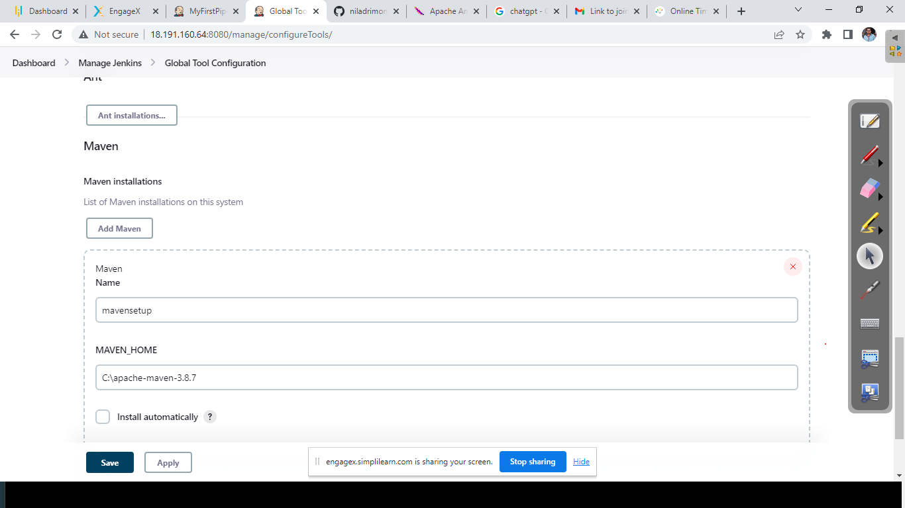

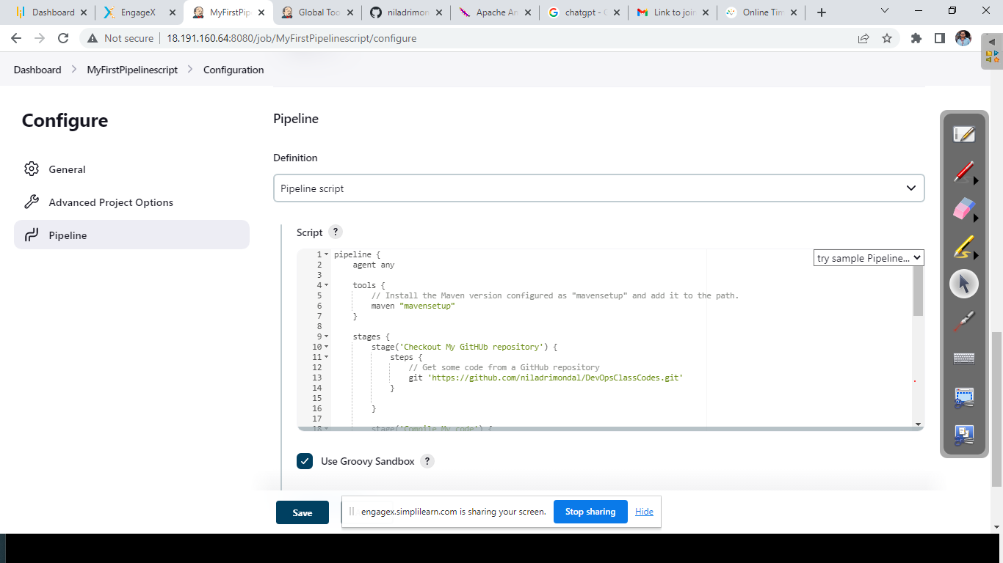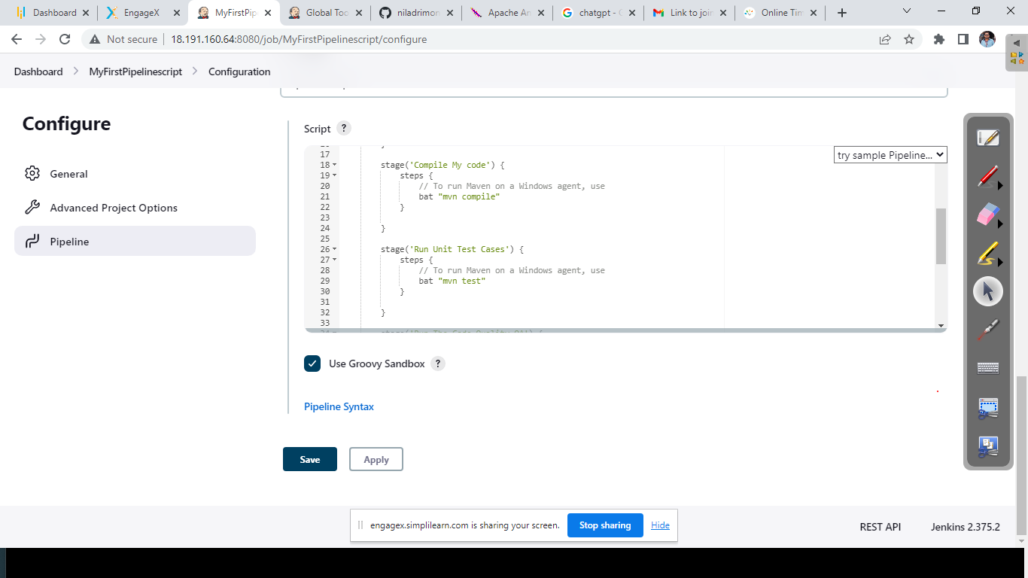

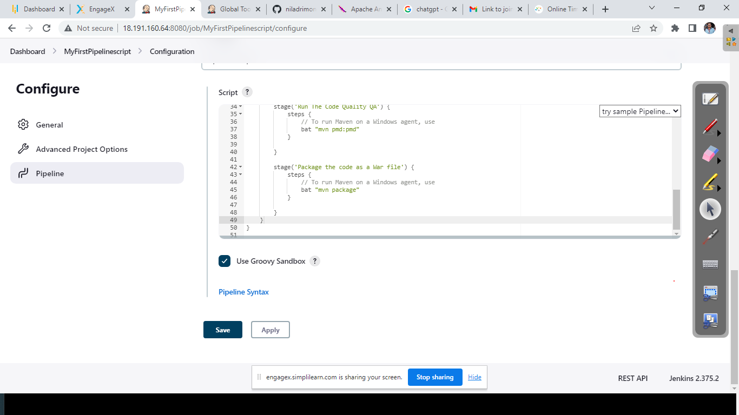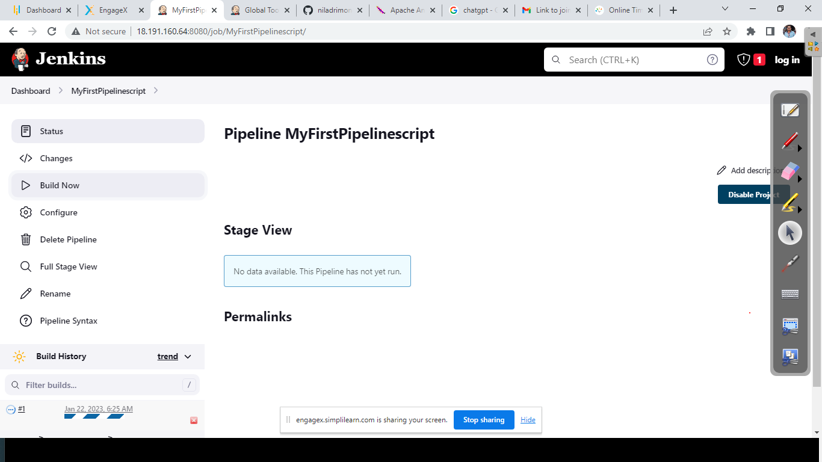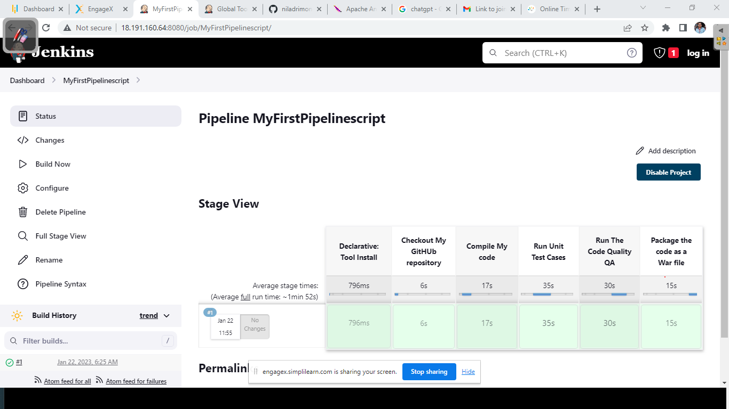

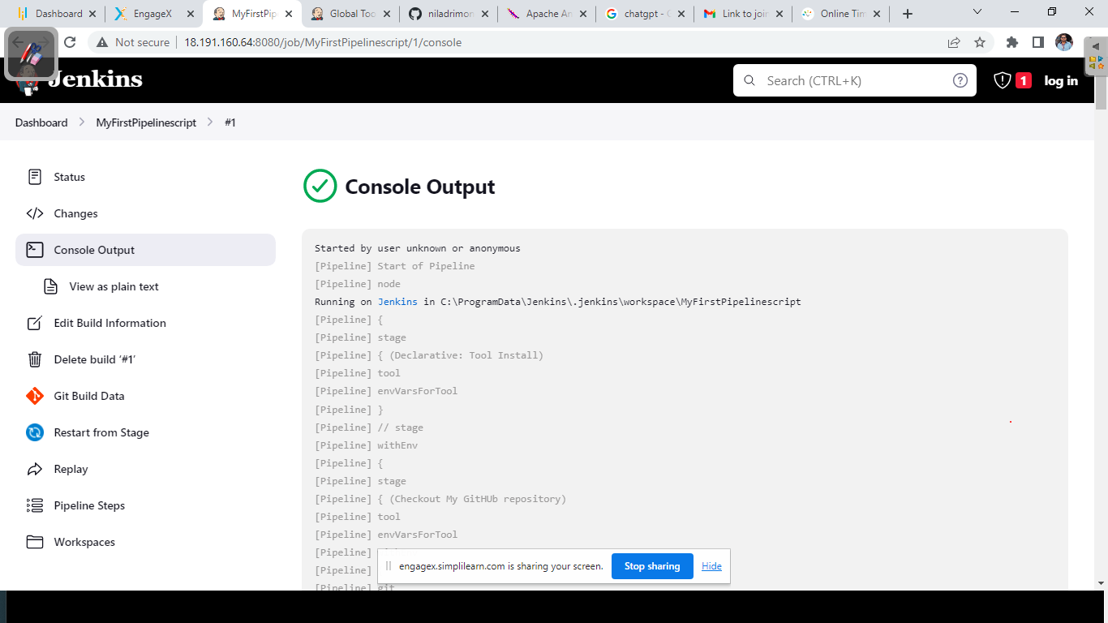

+++++++++++++++++++++Script++++++++++++++++++++++++

pipeline {

agent any

tools {

// Install the Maven version configured as "mavensetup" and add it to the path.

maven "mavensetup"

}

stages {

stage('Checkout My GitHUb repository') {

steps {

// Get some code from a GitHub repository

git 'https://github.com/niladrimondal/DevOpsClassCodes.git'

}

}

stage('Compile My code') {

steps {

// To run Maven on a Windows agent, use

bat "mvn compile"

}

}

stage('Run Unit Test Cases') {

steps {

// To run Maven on a Windows agent, use

bat "mvn test"

}

}

stage('Run The Code Quality QA') {

steps {

// To run Maven on a Windows agent, use

bat "mvn pmd:pmd"

}

}

stage('Package the code as a War file') {

steps {

// To run Maven on a Windows agent, use

bat "mvn package"

}

}

}

}

+++++++++++++++++++++++Script end++++++++++++++++++

+++++++++++++++++++++++++++++++++We are going to create a Secondary agent for my Jenkins++++++++

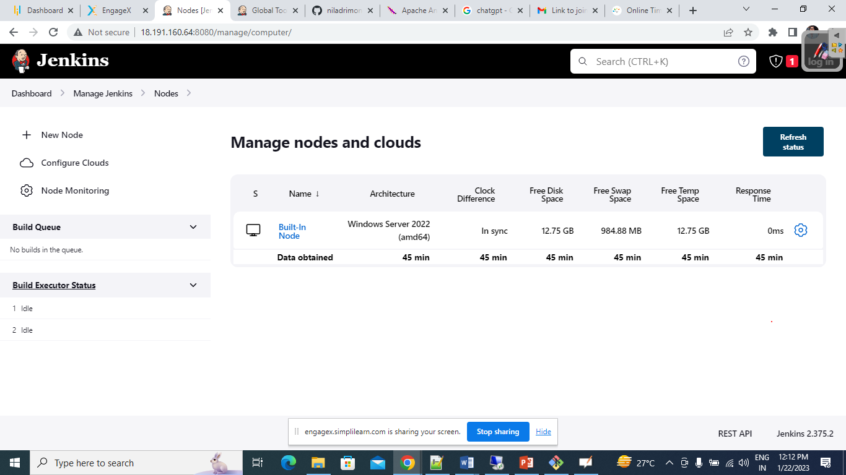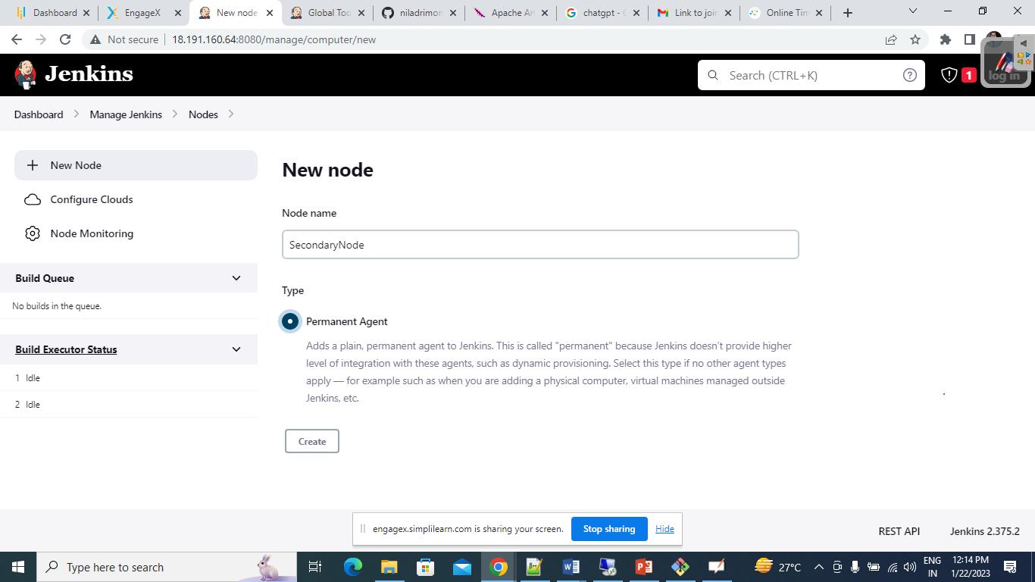

Once you create, then you need to specify the remote folder(in my case I have created a folder inside the VM where I have installed Jenkins)

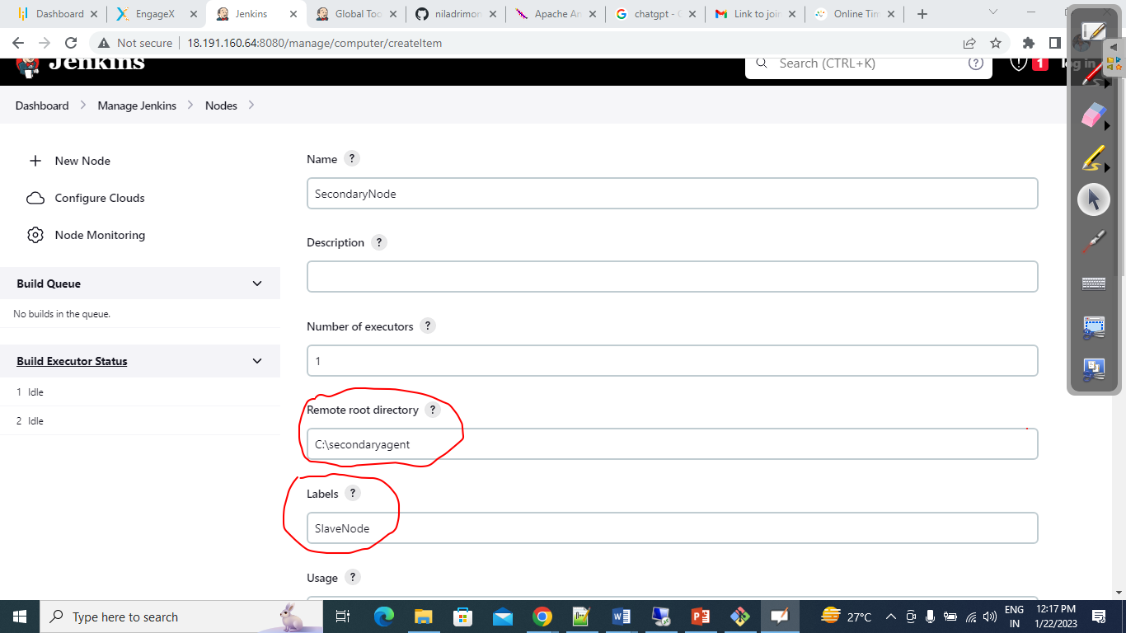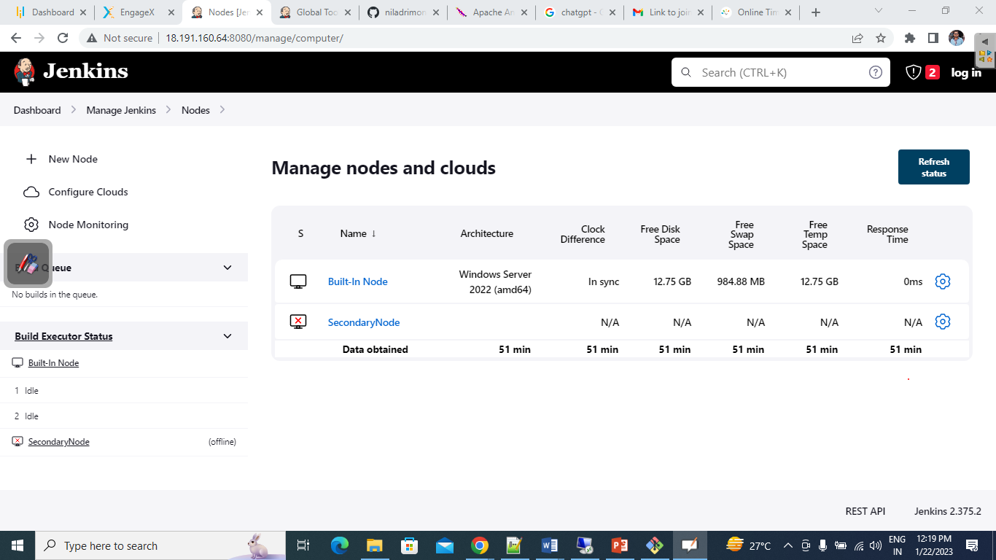

To Make the agent live, we need to run the agent inside the remote folder of the VM.

Download the agent form the below and upload the same in the folder from where you need to run the agent.

